Early Years Practice Procedures

Food Safety, Nutrition and Meeting Dietary Requirements
At St Margarets Pre School, we are committed to ensuring that all children’s dietary needs, allergies, medical conditions, cultural and religious food requirements are respected and safely managed.
We aim to provide a safe environment where children can enjoy food and drink while ensuring their health, wellbeing and inclusion.
We promote a balanced diet for children by offering a diverse selection of foods. Snack planning always incorporates one fruit or vegetable and one starchy item, such as plain savoury crackers or unsalted, unsweetened rice cakes, each day. We foster an environment where children are encouraged to try new foods while dining together within our setting. This approach supports children in sampling items they may be reluctant to eat at home; for instance, a child who is hesitant to try broccoli at home may be more willing to do so when observing their peers enjoying it.
This policy follows the guidance set out in the Early Years Foundation Stage (EYFS) and food safety regulations.

Collecting Dietary Information
When a child joins the setting, parents/carers are asked to provide information about:
- Food allergies or intolerances
- Medical dietary requirements
- Cultural or religious dietary needs
- Vegetarian or vegan preferences
- Any foods the child must not eat
This information is recorded on the child’s registration form and shared with all relevant staff.

Managing Allergies and Medical Diets
Where a child has an allergy or medical dietary requirement, the setting will:
- Record the allergy clearly on the child’s records
- Display allergy information confidentially for staff in food preparation areas
- Ensure all staff are aware of the child’s dietary needs
- Avoid providing foods that may cause a reaction
- Follow individual healthcare plans where required
- Ensure any prescribed medication (such as an epinephrine auto-injector) is accessible if required
Staff will remain vigilant during snack and mealtimes to ensure children do not share food.

Food Preparation and Safety
To reduce risks, the setting will:
- Follow good food hygiene practices
- Wash hands before handling food
- Prevent cross-contamination between foods
- Check ingredient labels for allergens where appropriate
- Store food safely and appropriately
Staff preparing food will be aware of children with specific dietary restrictions.

Snack and Mealtimes
Snack and mealtimes are important social learning opportunities. Staff will:
- Encourage children to develop healthy eating habits
- Ensure all children can safely participate
- Offer suitable alternatives where necessary
- Support children in learning about different foods and cultures
Children will always have access to their drinking bottles.

Food Brought from Home
Parents will be asked to:
- Avoid sending foods that may pose a serious allergy risk to other children
- Follow any guidance provided by the setting regarding allergen management.

Communication with Parents
We work closely with parents to ensure children’s dietary needs are met safely.
Parents must inform the setting if:
- Their child develops a new allergy
- Dietary requirements change
- Medical advice relating to diet is updated.
Staff Responsibilities
All staff will:
- Be aware of children’s dietary requirements
- Follow food hygiene and safety procedures
- Supervise children closely during eating times
- Ensure food is distributed safely and appropriately.
- Recognise the signs that a child has had enough and remove uneaten food without comment.
- Do not force children to eat anything they do not want to.
Snack and mealtimes are an important part of the day. Eating represents a social time for children and adults and helps children to learn about healthy eating. We aim to provide nutritious food, which meets the children’s individual dietary needs and preferences.
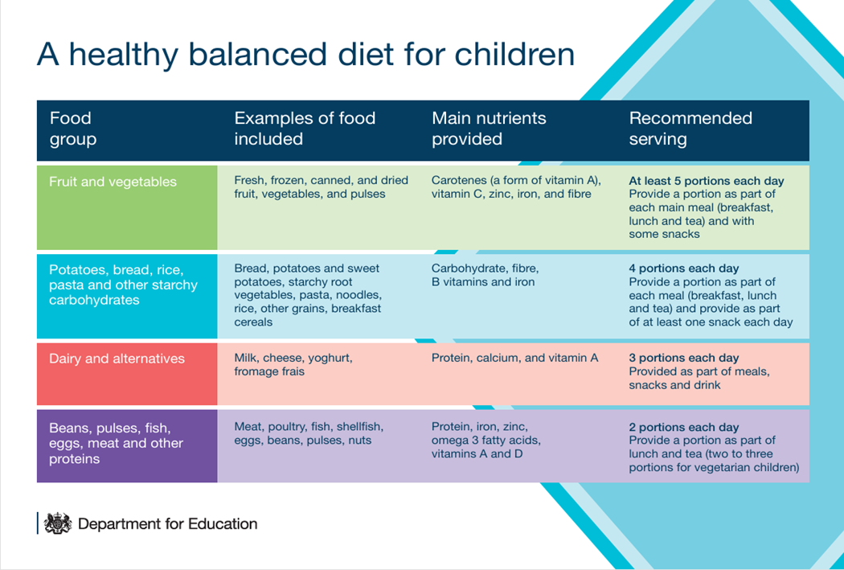
Monitoring and Review
This policy will be reviewed annually or sooner if required to ensure it reflects current best practice and the needs of children and families attending the setting.
- Policy Review Date: 09.03.2026
- Policy Approved By: Natalie Ruddock
- Next Review: 09.03.2027

